Nodejs is a runtime environment of javascript.

File system operations:

Require fs module

* Fs.writeFile to create a new file
* Fs.appendFile to add text in a file
* Fs.rename to rename a file
* Fs.copyFile
* Fs.unlink to delete a file

Middleware:

Middleware ak function hota h jo hr request or response pe run krta h.

HTTP Status Code:

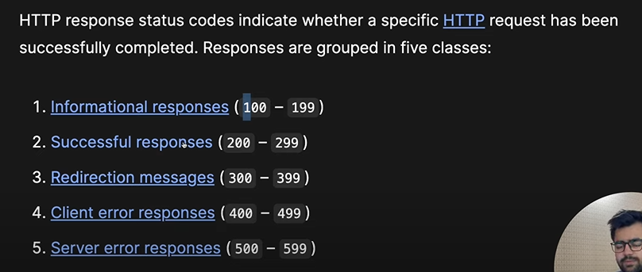

Mongoose:

* Mongoose ko pehly install krna h
* Phr require krna h
* Phr schema banta h mtlb structure
* Or phr model bnta h jis k through crud operations perform hoty hen

Authentication in nodejs:

there are two types of authentications in node js

1. Stateful (which maintains state or data or server side)

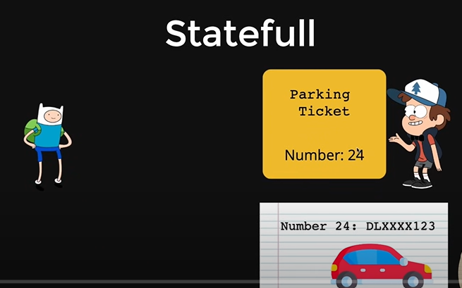

1. Stateless (which has no state)